UniBot

Frontier of Nano Technology

Sr. Nano Knights

Team Members:

Senthil Arasu J
Sahithian T R
Muhammad Fayaazullah F

Mentored by Mrs. Kamakshi J

From:

Vels Vidyashram
No.54, Darga Road, Pallavaram, Chennai, Tamil Nadu 600117
India

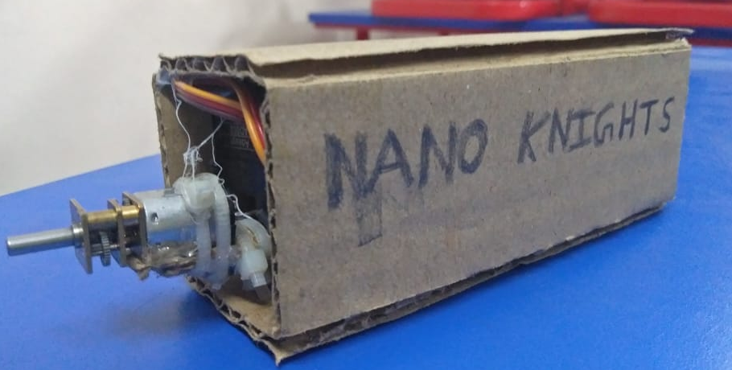

Table of Contents

- About Us
- The Need of this Project
- A Brief about the Project
- Social Impact
- Bibliography

About Us

The Team:

We have been a team for the past 2 years. We believe that our team is perfectly packed with all the characteristics necessary for winning. We have participated in various competitions and challenges, with which we have evolved to this stage with a lot of learning and experience. We are from a big state with varieties of diversity among our people, which is Tamil Nadu, speaking the one of the most ancient language in the world, Tamil. We have built our team structure such that it is ensured that all tasks reach the right hands with the right skill. We have split up each of the jobs in way that it is done most efficient as well as quicker. We believe that our team unity is the best of all others, in all the ways.

UniBot

What is UniBot?
UniBots are tiny wireless robots which are capable of very small movements. When a UniBots is single or individual, its uses are very limited. But when it joins with rest of its pals, it becomes an unimaginable power, with the only limitation of our imagination.

What can UniBot do?
UniBot is completely different from other robots since it falls into the category of self-assembling robots. It can form various structures through which it can drag, lift, push, pull or move objects easily. Since, UniBot is a shapeshifting robot, it can be used intensively in both industrial and everyday activities. Through this, we can solve various problems with one solution, for example, Moving containers, construction works, Transportation, Assembly line robots, etc. UniBot can also be used to assist or help elderly or handicapped people. UniBot proposes, efficient, sustainable, durable, effortless, convenient use of technology with enormous benefits for all sections of the society.

Importance of UniBot
As we have seen, UniBot is a complete all in one robot capable of delivering anything that we want. It stands as a solution for various challenges that we face in the world and society, in a very economical and energy efficient manner. The name UniBot comes from its unity. At their core, these remarkable machines embody the concept of autonomous construction, drawing inspiration from the self-organizing properties observed in natural systems, such as cellular organisms. By harnessing the power of artificial intelligence, advanced material science, and decentralized control algorithms. these machines not only perform predefined tasks but also exhibit emergent behaviours, adaptability, and resilience in dynamic environments.

Key Features of UniBot
- Completely Wireless – Wi-Fi Communication
- Can be controlled via different remote systems like Neuralink or AI
- Sustainable energy source – Solar power, Causing no harm to Earth
- AutoDock – Automatic wireless charging docking
- Different/customized versions of UniBot – According to the needs of the usage fields.

UniBot - Synopsis

Introduction
UniBot possess the immense power, technology and structure to transform our world into a simple, quick and effortlessly functioning one. UniBot has been engineered to provide the most beneficial and efficient design ranging from exterior design, mechanical design to software design. Most of the swarm robots can form only 2D structure, but UniBot can form and operate 3D structures, making it as a real world functional robot.

Objective
The main objective of this project is to remove the aspect of robotics that says that robots can move only on fixed axes, making it non-flexible as compared to a human being’s flexibility and movements which brings a barrier that differentiates artificial simulation through robotics from real world organism’s functioning, that is making robots to function on different moving axes, thus making them most flexible and customizable robots that allows us to form any structure and move in any way.

Inspiration
The main reason or cause of this project is that it is mostly said that “Robots will never be able to simulate the living organisms, Humans.” But we present this project as proof that robotics can not only simulate the living, but also “emulate” them. For example, taking a microscopic organism Amoeba. When Amoeba finds a food, it forms a structure called pseudopodia, which are finger like projects which arise from the body of the Amoeba to capture the food. The formation of the pseudopodia in amoeba, raised a thought, is it impossible to do that through the technology that humans have created till date?
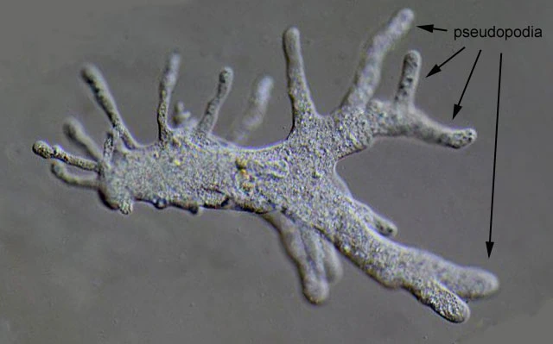

We, Humans our self, are made up of very tiny structures, cells that function together to accomplish a big task. This is the key concept of UniBot and its functioning.

Methodology

Structure
The initial structure of the bot was chosen as hexagonal cylinder, since hexagonal structures are very efficient and easy at interlocking/joining with each other.
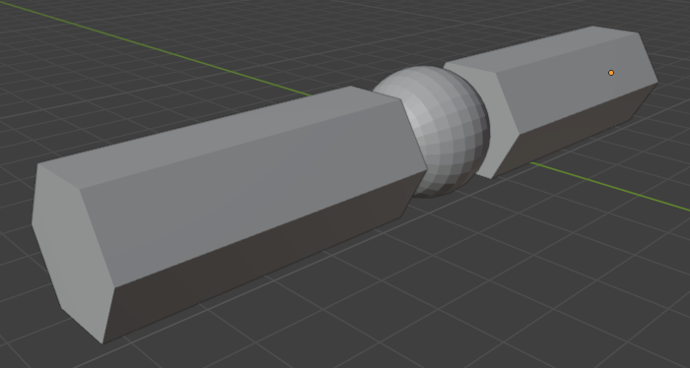
Later on, due to shortage of time and lack of funding, the design was downgraded to a minimalistic one with DIY Acrylic cuboids instead of 3D printed hexagonal cylinders.
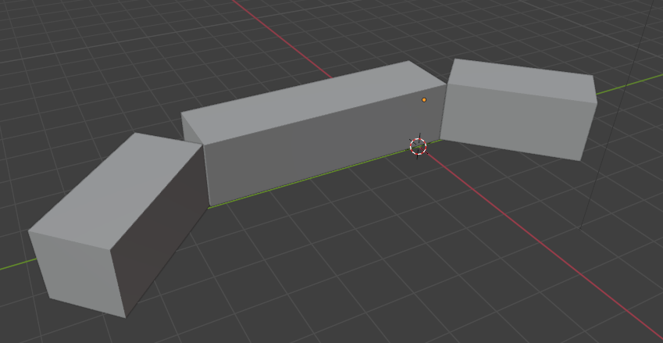

Mechanical Reference/Hardware specifications
The internal mechanical prototyping design of the project is in such a way that a single robot provides 2 axes movement in bending and 2-wheel rotational movement with the help of 2 AD002 servos and 2 N20 Geared motors. These servos and motors were chosen to provide additional torque to move easily under high pressure or force. In future prototyping, we are using custom designed metallic gears to reduce the size of the servos and motors.
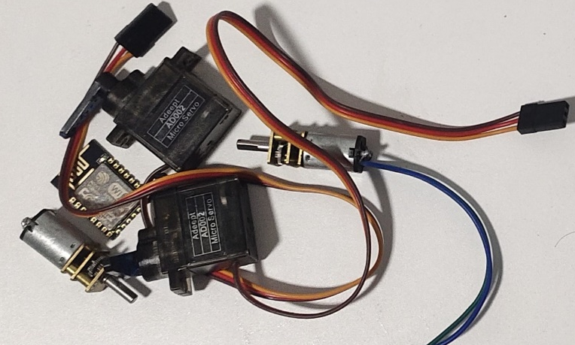

Self-Linking/Attaching/Interlocking/Self-Assembling technology
The initial prototype model is not yet fully capable of the self-linking technology, but it has engineered in the present to adapt the self-linking technology in the future progresses. Presently, there are two most efficient models that we could adapt in the future to implement this key technology, that is Electro-magnetism and Electro-Permanent-Magnetism. The main reason for choosing non-contact attaching is that it does not require any mechanical systems which really reduces the complexity of project which promotes the scope of size reduction of the project for future expectations.

Microcontroller unit
The main MCU of the project, ESP8266, is fully customized and used as a standalone board along with integrated L293D motor driver, with MicroPython runtime framework. ESP has been chosen for its single digit standby current consumption and excellent Wi-Fi connectivity manipulation and user friendly boot loading interface along with low latency communications.
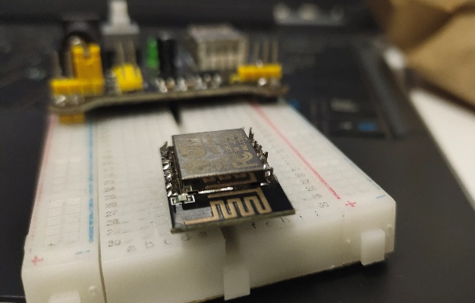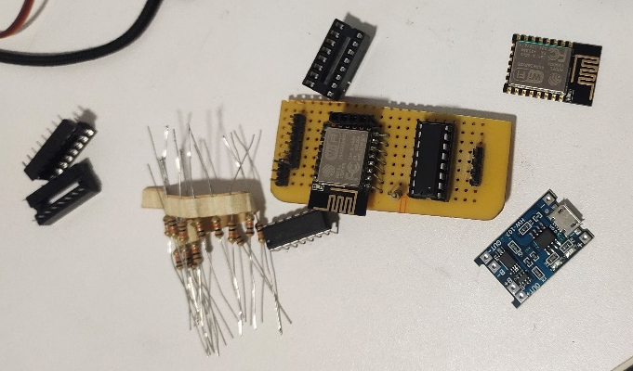
Initial Prototyping Final Custom Board

Materials Used (Per Bot):
- ESP8266 12-F Wi-Fi Micro Controller
- L293D Motor Driving with IC Base
- Prototyping Dot PCB (Later on Printed customized PCB)
- 10K Resistors
- Acrylic sheets
- HW107 Battery charging module
- 3.7V 18650 Battery
- FTDI USB to Serial Converter

Software/Coding
This project is completely coded on Python3 both on MCU and Remote Controller. The main advantage of Python is that it allows the developer to code efficiently and effectively with ease, less time consuming and easy to modify without much syntax problems. The programs are made through intensive testing to detect any flaws or bugs within the control algorithm and transmission protocols. The Python controller make use of the pynput library to take hold of the keyboard keys. Both the Controller and the receiver are programmed to communicate via TCP sockets with an additional auto re-connect functionality without any data lose. The code is publicly available at the GitHub repository https://github.com/parzival43/unibot.

Challenges
- Designing the power supply system of the bot was a difficult one. The MCU Esp8266 needed a 3.3v power supply, but the servos, motor and the motor driver, needed 5v power supply, but the 3.7v battery neither supported both of them. We have specifically design a power supply routing system that gave us both the 5v and 3.3v
- Physical structure design of the robot had been an inconsistent and variable one since, the bot has to accommodate both individual movement and self-linking/self-assembling structure in order to combine with other robots.
- Energy Efficiency: Self-assembling robots typically operate on limited battery power, so optimizing energy efficiency is critical for prolonging their operational lifespan. This includes developing efficient locomotion mechanisms, power management strategies, and energy-aware algorithms.
- Robustness to Environmental Variability: Self-assembling robots may operate in diverse and unpredictable environments, so they need to be robust to changes in lighting conditions, terrain, temperature, and other environmental factors. This requires robust perception algorithms and adaptive control strategies.
- Human-Robot Interaction: In some applications, self-assembling robots may need to interact with humans or other robots in a collaborative manner. Designing intuitive interfaces and developing algorithms for human-robot interaction (HRI) is essential for enabling seamless collaboration, which is a crucial operation mechanism of a self-assembling robot.
- This one is a technical problem, that is the output voltage from the ESP8266 MCU is 3.3v but L293d operated on 5v. So the motor driver began to range this voltage from 0-5v which reduced the speed of the geared motors which were already slow.

Research and Analysis
According to the research conducted by our team, there were only a few types of robots, but those were not completely self-assembling robots, accurately functioning or environmentally adaptable.
Here is a list of robots that were research by us.
- M-Blocks 2.0: these robots generate movement in single direction through the momentum generated due to breaking of the flywheel inside the bot 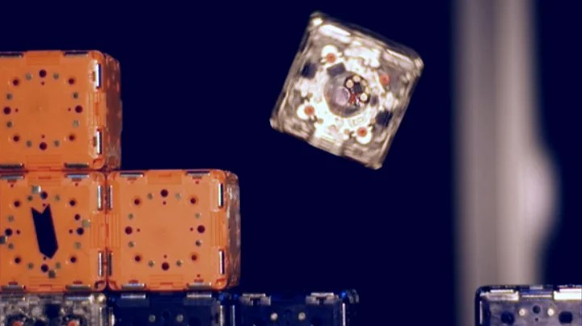
- KiloBots: These robots generate movement through vibrations on their legs, but they are limited to only 2D structures. 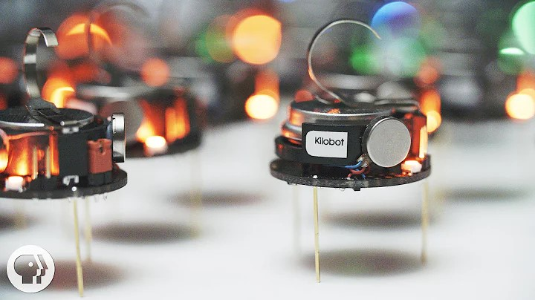
- MIT Voxels: These voxels need a standardised surface for them to work
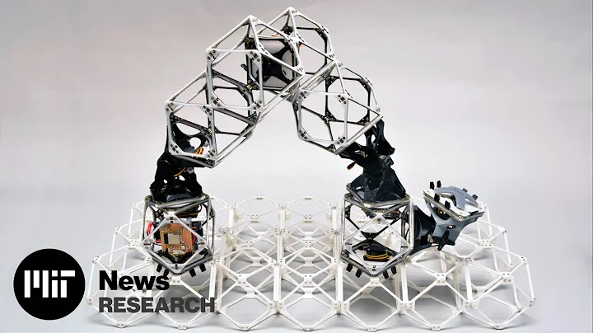

Social impact & innovation
Self-assembling robots represent a significant leap forward in robotics, with profound potential for social impact and innovation across various fields. Here's a breakdown of their implications:

1. Disaster Response: One of the most immediate applications of self-assembling robots is in disaster response. These robots can autonomously navigate through debris and assemble into structures to aid in search and rescue missions. Their ability to adapt to changing environments and collaborate with each other can significantly improve the efficiency and effectiveness of rescue operations in scenarios such as earthquakes, hurricanes, or industrial accidents.

2. Construction and Infrastructure: Self-assembling robots have the potential to revolutionize the construction industry by automating the assembly of structures. From building temporary shelters in emergency situations to constructing large-scale infrastructure projects, these robots can work collaboratively to reduce construction time, costs, and human labour. Additionally, their flexibility allows for the creation of novel architectural designs that were previously impractical or impossible to build.

3. Healthcare: In the healthcare sector, self-assembling robots can be utilized for targeted drug delivery, minimally invasive surgeries, and even tissue engineering. These robots can navigate through the body, assemble into complex structures, and perform precise tasks with minimal intervention. This technology has the potential to revolutionize medical treatments by improving precision, reducing recovery times, and minimizing the risk of complications.

4. Environmental Monitoring and Conservation: Self-assembling robots can play a crucial role in environmental monitoring and conservation efforts. Equipped with sensors and communication devices, these robots can autonomously navigate through ecosystems, assemble into sensor networks, and collect data on environmental parameters such as temperature, humidity, and pollution levels. This information can be used to monitor ecosystem health, detect environmental threats, and guide conservation initiatives.

5. Space Exploration: In the field of space exploration, self-assembling robots hold promise for autonomous construction of habitats and infrastructure on other planets or moons. By leveraging local resources and autonomously assembling structures, these robots can enable long-term human habitation beyond Earth, supporting scientific research, resource extraction, and colonization efforts.

6. Education and Research: Self-assembling robots also offer valuable educational and research opportunities. By studying their behaviours, interactions, and self-assembly mechanisms, researchers can gain insights into collective intelligence, swarm robotics, and emergent behaviours in complex systems. Moreover, these robots can serve as educational tools to inspire interest in STEM fields and foster creativity and problem-solving skills in students.

Key Innovation: To lead this project in a sustainable and energy efficient way, we are making the surfaces of the bot panelled with solar cells. This helps the bot to recharge itself when exposed to sunlight. This may not work under all conditions or environments, but it does make a change that brings a branch of sustainability into our robot, making it eco-friendly for all environments with easy adaptation. The next key in this project is the AI integration. Harnessing the power of AI, once it is well trained and ready for industrial action, the UniBots will effortlessly form the most beautiful and complex structure without any human intervention.

A Quick Demonstration:
Here is a quick demonstration of our first cardboard prototype UniBot. In this video we can clearly see the control mechanisms and physical movements of the robot.
https://youtu.be/HQLhn6Kf63Y

Conclusion
In conclusion, self-assembling robots represent a paradigm shift in robotics. Overall, the social impact and innovation potential of self-assembling robots are vast, offering transformative capabilities across various industries and domains. By harnessing the power of autonomy, adaptability, and collaboration, these machines have the potential to reshape the way we manufacture products, construct buildings, caring for environmental conservation, explore the cosmos, and beyond. As research and development in this field continue to advance, we can expect to see increasingly sophisticated applications that address some of the most pressing challenges facing society. As researchers continue to push the boundaries of innovation and discovery, the future holds boundless possibilities for self-assembling robots to unlock new frontiers and redefine the limits of what is possible in the realm of robotics and beyond.

Bibliography

Physical References
- M-Blocks 2.0: https://www.youtube.com/watch?v=hI5UDKaWJOo
- KiloBots Swarm: https://www.youtube.com/watch?v=JmyTJSYw77g
- MIT Assembler robots: https://www.youtube.com/watch?v=G94FDMGLwCc
- Self-assembling Materials Reactive to Energy: https://www.youtube.com/watch?v=GIEhi_sAkU8

An Inspirational reference:
Big Hero 6 (MicroBots)
https://www.youtube.com/watch?v=fsVJuN75vzE&t=37s

Datasheet references:
Esp8266: https://docs.ai-thinker.com/_media/esp8266/docs/esp-12f_product_specification_en.pdf
https://www.espressif.com/sites/default/files/documentation/0a-esp8266ex_datasheet_en.pdf
L293D:
https://www.ti.com/lit/ds/symlink/l293d.pdf?ts=1714886434219&ref_url=https%253A%252F%252Fwww.ti.com%252Fproduct%252FL293D

Project Code
https://github.com/parzival43/unibot
Hosted at GitHub

Esp8266 Bootload Guide:
https://docs.espressif.com/projects/esptool/en/latest/esp8266/advanced-topics/boot-mode-selection.html
https://www.youtube.com/watch?v=_iX67plFeLs
https://docs.micropython.org/en/latest/esp8266/tutorial/intro.html
https://www.hackster.io/harshmangukiya/program-esp8266-esp-12e-with-arduino-using-ftdi-cable-2310c9

Python3 Support of ESP8266: MicroPython Firmware
https://micropython.org/download/ESP8266_GENERIC/

PC Controller IDE:
PyCharm https://www.jetbrains.com/pycharm/

ESP8266 MicroPython IDE:
https://thonny.org/

